**Adagio – AR (Process Bank Deposits)**

* ADAGIO RECEIVABLES MODULE
* CASH – NEW - OK  
  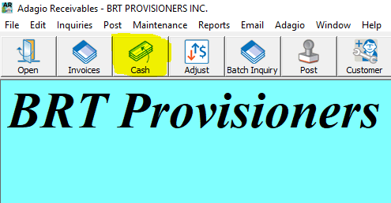
* SELECT CUSTOMER CODE

*\*\*F6 TO SEARCH NAME OF CUSTOMER*

* ENTER CHEQUE # (from the rcvd check)
* ENTER DATE – when cheque will be deposited to the bank
* PAYMENT – enter the amount received/deposited to bank
* Highlight the row in the list below for the invoice being paid and Double Click, then OK + OK  
   *\*\*Repeat for additional invoices being paid on check*
* Close
* LISTING - Print
* Tear bottom part of received check & staple behind the Deposit Listing

*\*\* (if none or missing then photocopy cheque)*

* File in Deposits (bottom drawer under printer) – most current at front
* Stamp with correct account (match # with chequebook) – Stamp on back of cheque(s)
* Close Screen & Post – Click Yes